**HW 3 -3600 Operating System**

**Submit your answers in Canvas as a pdf document on or before (02/27/2021).**

1. A MLF algorithm uses 5 priority levels. At level 5, a process executes for Q = 1 ms. At each of the lower levels the quantum is doubled (2Q, 4Q, 8Q, 16Q).

The following processes are to be scheduled:

|  |  |  |
| --- | --- | --- |
| Process | Arrival | Total CPU time |
| p1 | 0 | 1 |
| p2 | 1 | 3 |
| p3 | 1 | 14 |

After termination, process p1 blocks for 4 ms and then reenters the queue again at level 5. Similarly, process p2 blocks for 5 ms and then reenters the queue again at level 5

1. Draw a Gantt Chart (timing diagram) for the first 33 ms. On each of the 3 lines (one per process) show when the process is running and at which priority level. **(15 points)**

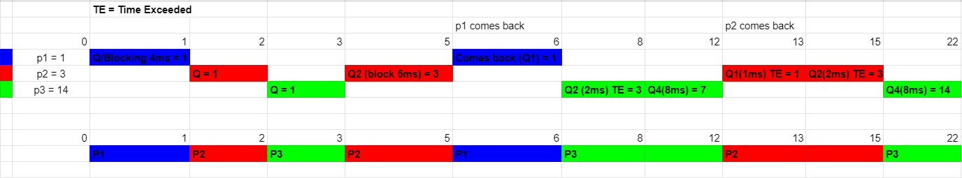

1. Determine the Average Turn Around Time for each process. Make a table of Arrival time,Completion Time, Turn Around Time and WaitTime of the processes **(10 points)**

|  |  |  |  |  |  |
| --- | --- | --- | --- | --- | --- |
| **Program** | **Arrival** | **Burst Time** | **Completion** | **Turnaround Time** | **Waiting Time** |
| **p1** | 0 | 1 | 6 | 6 - 0 = 6 | 6 - 1 = 5 |
| **p2** | 1 | 3 | 15 | 15 - 1 = 14 | 14 - 3 = 11 |
| **p3** | 1 | 14 | 22 | 22 - 1 = 21 | 21 - 14 = 7 |

**What to turn in Canvas:**

Solution as a pdf document.